# **WebLogic, SOA, OIM Bundle Patching Document**

# **BACKUP OIM File System**

a) Create a backup folder under /opt/oracle directory

b) Backup middleware and user_projects directory under /opt/oracle directory to the backup folder

$cd /opt/oracle

$tar -cvzf /opt/oracle/backup/oimbkp.tar.gz /opt/oracle/middleware /opt/oracle/user_projects

# **Path for Patch binaries**

/tmp/patches

1. p24667634_1036_Generic.zip
2. p25247644_111190_Generic.zip
3. p25038775_111230_Generic.zip

# **Bundle Patch Requirements**

* Verify the OUI Inventory. To apply patches, OPatch requires access to a valid OUI Inventory. To verify the OUI Inventory, run the following command in OIM_ORACLE_HOME/OPatch for verifying the existing Patch-

*cd /opt/oracle/middleware/Oracle_IDM1/OPatch*

*./opatch lsinventory*

If the command returns an error or you cannot verify the OUI Inventory, contact Oracle Support. You must confirm the OUI Inventory is valid before applying this bundle patch.

* Confirm the opatch and unzip executables exist and appear in your system PATH, as both are needed to apply this bundle patch. Execute the following commands:

*which opatch*

*which unzip*

Both executables must appear in the PATH before applying this bundle patch.

* Ensure that there are no pending JMS messages in Oracle Identity Manager Server. You can monitor JMS messages with WebLogic console.

# **Applying WebLogic Patch- 24667634**

Oracle WebLogic Server Patch Set Update 10.3.6.0.170117 README

=========================================================

This README provides information about how to apply Oracle WebLogic Server

Patch Set Update 10.3.6.0.170117. It also provides information about reverting to

the original version.

Released: Jan, 2017

Smart Update Details of Oracle WebLogic Server Patch Set Update 10.3.6.0.170117

--------------------------------------------------------------------------

PATCH_ID - XIDD

Patch number - 24667634

Preparing to Install Oracle WebLogic Server Patch Set Update 10.3.6.0.170117

-----------------------------------------------------------------------

- WebLogic Server Patch Set Update (PSU) can be applied on a per-domain basis

(or on a more fine-grained basis), Oracle recommends that PSU be applied on an installation-wide basis.

PSU applied to a WebLogic Server installation using this recommended practice

affect all domains and servers sharing that installation.

- Login as same "user" with which the component being patched is installed.

- Stop all WebLogic servers.

- Remove any previously applied WebLogic Server Patch Set Update and associated overlay patches

Installing Oracle WebLogic Server Patch Set Update 10.3.6.0.170117

-------------------------------------------------------------

- unzip p24667634_1036_Generic.zip to {MW_HOME}/utils/bsu/cache_dir or any local directory

Note: You must make sure that the target directory for unzip has required write and executable permissions

for "user" with which the component being patched is installed.

Patching Steps:

----------------

1. Stop Oracle Identity Manager managed Servers, SOA managed Servers and WebLogic Admin Server.

(Stop Order 🡪 oim_server1, soa_server1, oim_server2,soa_server2 and Admin server )

2. Copy p24667634_1036_Generic.zip to /opt/oracle/middleware/utils/bsu/cache_dir/

3. unzip p24667634_1036_Generic.zip

4. Navigate to /opt/oracle/middleware/utils/bsu

5. Execute ./bsu.sh -install -patch_download_dir=/opt/oracle/middleware/utils/bsu/cache_dir -patchlist=XIDD -prod_dir=/opt/oracle/middleware/wlserver_10.3 -log=/opt/oracle/middleware/utils/bsu/

If we get conflict with other patches:

execute the following command with the respective conflicting patches for example:

./bsu.sh -remove -patchlist=ZARV,CM69,XA6W,NPM3,FSG4,IMWL,56MM -prod_dir=/opt/oracle/middleware/wlserver_10.3

where, patch ids - ZARV,CM69,XA6W,NPM3,FSG4,IMWL,56MM are conflicting with the patch that we are installing XIDD

6. After removing the conflicting patch again execute below command

./bsu.sh -install -patch_download_dir=/opt/oracle/middleware/utils/bsu/cache_dir -patchlist=XIDD -prod_dir=/opt/oracle/middleware/wlserver_10.3 -log=/opt/oracle/middleware/utils/bsu/

7. Restart all WebLogic servers

8. Navigate to /opt/oracle/middleware/wlserver_10.3/server/bin and run ./setWLSEnv.sh

9. cat /opt/oracle/middleware/patch_wls1036/registry/patch-registry.xml

Reference: BSU Command line interface

http://docs.oracle.com/cd/E14759_01/doc.32/e14143/commands.htm

Post-Installation Instructions

------------------------------

a) Restart all WebLogic servers. (In our case needs to be restart once SOA and OIM patches also applied in phxiampas63.pii.star)

b) The following command is a simple way to determine the application of WebLogic Server PSU.

$ . $WL_HOME/server/bin/setWLSEnv.sh

$ java weblogic.version

In the following example output, 10.3.6.0.170117 is the installed WebLogic Server PSU.

WebLogic Server 10.3.6.0.170117 PSU Patch for BUG24667634

Uninstalling Oracle WebLogic Server Patch Set Update 10.3.6.0.170117

---------------------------------------------------------------

Rollback Steps:

--------------

1. Stop all WebLogic Servers

2. Navigate to /opt/oracle/middleware/utils/bsu and execute:

./bsu.sh -remove -patchlist=XIDD -prod_dir=/opt/oracle/middleware/wlserver_10.3

# **Applying SOA Patch- 25247644**

**Important-** Copy the patch from SVN or Oracle Support or from lower environment to the server on which need to apply the patches. Copy the patches on below location and unzip it.

*cd /opt/oracle/software/OIMPatching*

*unzip p25247644_111190_Generic.zip*

This step must be executed for each OIM_ORACLE_HOME in the installation topology nodes irrespective of whether Oracle Identity Manager server is being run in the node or not.

1. Stop the Admin Server, all Oracle Identity Manager managed servers, and all SOA managed servers.

2. Create a directory for storing the unzipped bundle patch. This document refers to this directory as PATCH_TOP.

*$ cd /opt/oracle/middleware/Oracle_SOA1/OPatch/*

*$ mkdir PATCH_TOP*

3. Copy the Patch "*25247644*" in PATCH_TOP folder

*$ cd /opt/oracle/software/OIMPatching/25247644*

*$ cp -r 25247644 /opt/oracle/middleware/Oracle_SOA1/OPatch/PATCH_TOP*

4. Move to the directory where the patch is located.

*$ cd /opt/oracle/middleware/Oracle_SOA1/OPatch/PATCH_TOP/25247644*

5. Set the ORACLE_HOME directory in your system. For example:

*$ export ORACLE_HOME=/opt/oracle/middleware/Oracle_SOA1*

*$ export ORACLE_HOME=/opt/oracle/middleware/oracle_common*

6. Apply the bundle patch to the ORACLE_HOME using the following command for WebLogic:

*$ opatch apply*

**Note:** if it will show command not found then run below command-

*$ echo $PATH*

check if OPatch is set if Path not set then run below command

*$ export PATH=$PATH:/opt/oracle/middleware/Oracle_SOA1/OPatch*

*$ export PATH=$PATH:/opt/oracle/middleware/oracle_common/OPatch*

*$echo $PATH*

*$ opatch apply*

# **Applying OIM Bundle Patch - 25038775**

6.1 Stage 1: Patching the Oracle Binaries (OPatch Stage)

**Important-** Copy the patch from SVN or Oracle Support or from lower environment to the server on which need to apply the patches. Copy the patches on below location and unzip it.

*cd /opt/oracle/software/OIMPatching*

*unzip p25038775_111230_Generic.zip*

This step must be executed for each OIM_ORACLE_HOME in the installation topology nodes irrespective of whether Oracle Identity Manager server is being run in the node or not.

1. Stop the Admin Server, all Oracle Identity Manager managed servers, and all SOA managed servers.

2. Create a directory for storing the unzipped bundle patch. This document refers to this directory as PATCH_TOP.

*$ cd /opt/oracle/middleware/Oracle_IDM1/OPatch/*

*$ mkdir PATCH_TOP*

3. Copy the Patch "25038775" in PATCH_TOP folder

*$ cd /opt/oracle/software/OIMPatching/25038775/iamsuite/patch/oim*

*$ cp -r 24927639 /opt/oracle/middleware/Oracle_IDM1/OPatch/PATCH_TOP*

4. Move to the directory where the patch is located.

*$ cd /opt/oracle/middleware/Oracle_IDM1/OPatch/PATCH_TOP/24927639*

5. Set the ORACLE_HOME directory in your system. For example:

*$ export ORACLE_HOME=/opt/oracle/middleware/Oracle_IDM1*

6. Apply the bundle patch to the ORACLE_HOME using the following command for WebLogic:

*$ opatch apply*

**Note:** if it will show command not found then run below command-

*$ echo $PATH*

check if OPatch is set if Path not set then run below command

*$ export PATH=$PATH:/opt/oracle/middleware/Oracle_IDM1/OPatch*

*$echo $PATH*

*$ opatch apply*

7. start WebLogic Admin Server, SOA managed Servers, and Oracle Identity Manager managed Servers.

(Start Order 🡪 Admin server, soa_server1, oim_server1, soa_server2 and oim_server2)

All above steps are captured in below screenshot-

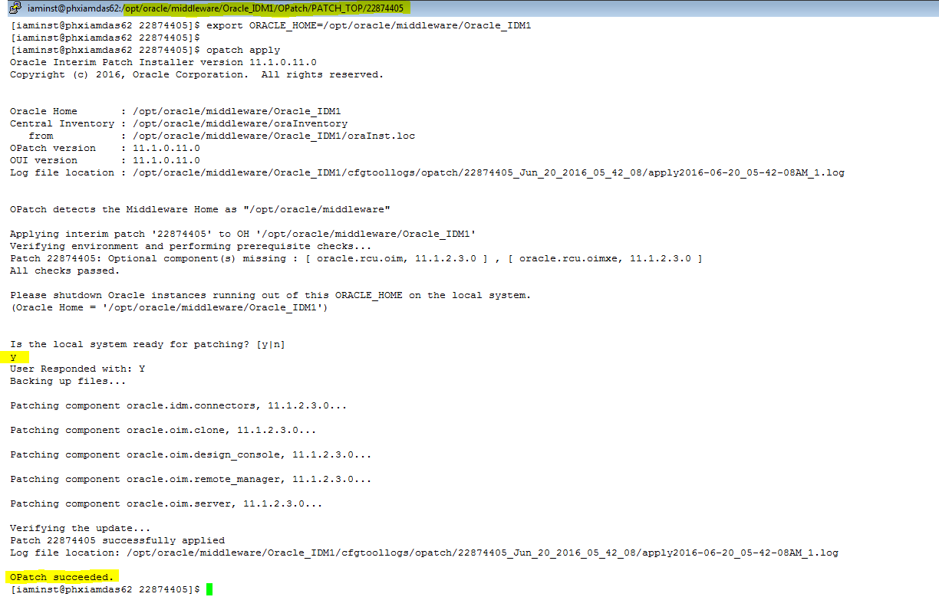

**Note:**

* Ensure the OPatch executables appear in your system PATH.
* If OPatch fails with error code 104, cannot find a valid oraInst.loc file to locate Central Inventory, include the -invPtrLoc argument, as follows:

opatch apply -invPtrLoc ORACLE_HOME/oraInst.loc

* Ignore the following warning that is displayed while applying OPatch:

**OUI-67644:**

Given patch "24927639" is a bug superset of patches "22552476 & 22874405" but is not a file superset. When OPatch starts, it will validate the patch and ensure there are no conflicts with the software already installed in the ORACLE_HOME. OPatch categorizes two types of conflicts:

* Conflicts with a patch already applied to the ORACLE_HOME. In this case, stop the patch installation and contact Oracle Support.
* Conflicts with subset patch already applied to the ORACLE_HOME. In this case, continue the install, as the new patch contains all the fixes from the existing patch in the ORACLE_HOME. The subset patch will automatically be rolled back prior to the installation of the new patch.

**Important Note for Clustered Environement: (For Stage and Production)**

◦For clustered and multi-node installation of Oracle Identity Manager, this step must be run on all the OIM_ORACLE_HOME directories on which Oracle Identity Manager is installed.

Means that, need to apply in phxiampas63.pii.star and phxiampas64.pii.star

1. Again Bring down oim_server2 and soa_server2 managed servers
2. Apply the patch for SOA and OIM in phxiampas64.pii.star
3. Bring up the servers, oim_server2 and soa_server2 managed servers.
   1. **Stage 2: Filling in the patch_oim_wls.profile File**

**Note: Before doing this, verify the server’s status, all servers are up and running.**

Log in to putty, for phxiampas63.pii.star

Move to the OIM_ORACLE_HOME/server/bin/ directory, and enter the details provided in the patch_oim_wls.profile file. The patch_oim_wls.profile file contains the sample values.

*Cd /opt/oracle/middleware/Oracle_IDM1/server/bin*

After updating the “*patch_oim_wls.profile*” file same as highlighted value in the screenshot, run the below command to check the file is updated or not.

The following are Stage DB details:

Host name: phxiampdb-orascan.pii.star

service name: IAM_PIAMPRD1

port: 1521

OIM schema name: PRODOIM_OIM

OIM MDS Schema: PRODOIM_MDS

[iaminst@phxiamsas63 bin] $ vi patch_oim_wls.profile

ant_home=/opt/oracle/middleware/modules/org.apache.ant_1.7.1

java_home=/opt/oracle/java/

mw_home=/opt/oracle/middleware

oim_oracle_home=/opt/oracle/middleware/Oracle_IDM1

soa_home=/opt/oracle/middleware/Oracle_SOA1

weblogic.server.dir=/opt/oracle/middleware/wlserver_10.3

domain_home=/opt/oracle/user_projects/domains/OIMDomain1

policybackup.required=true

#weblogic configuration variables

weblogic_user=weblogic

#Password is optional, if you want to give it on terminal itself leave it commented. Otherwise uncomment it.

#weblogic_password=<enter-password>

soa_host= phxiampas63.pii.star

soa_port=8001

#DB configuration variables

operationsDB.user= PRODOIM_OIM

# Database password is optional. if you want to give it on terminal itself leave it commented. Otherwise uncomment it.

#OIM.DBPassword=<enter-pasword>

operationsDB.host= phxiampdb-orascan.pii.star

operationsDB.serviceName= IAM_PIAMPRD1

operationsDB.port=1521

mdsDB.user= PRODOIM_MDS

#Password is optional, if you want to give it on terminal itself leave it commented. Otherwise uncomment it.

#mdsDB.password=<enter-pasword>

mdsDB.host= phxiamsdb-orascan.pii.star

mdsDB.port=1521

mdsDB.serviceName= IAM_PIAMPRD1

oim_username=xelsysadm

#Password is optional, you can put it here also (and also uncomment the line) otherwise leave it as it is and you will get prompted for it during runtime as hidden string

#oim_password=<password>

oim_serverurl=t3://phxiampas63.pii.star:14000

**[iaminst@phxiamdas62 bin]$ more patch_oim_wls.profile**

# For passwords if you dont want to put password </optional> in this file just comment it out from here, you will be promted for it in rumtime.

**#Neccessary env variables [Mandatory]**

ant_home=/opt/oracle/middleware/modules/org.apache.ant_1.7.1

java_home=/opt/oracle/java/jdk1.7.0_80

mw_home=/opt/oracle/middleware

oim_oracle_home=/opt/oracle/middleware/Oracle_IDM1

soa_home=/opt/oracle/middleware/Oracle_SOA1

weblogic.server.dir=/opt/oracle/middleware/wlserver_10.3

domain_home=/opt/oracle/user_projects/domains/OIMDomain1

policybackup.required=true

#weblogic configuration variables

weblogic_user=weblogic

#Password is optional, if you want to give it on terminal itself leave it commented. Otherwise uncomment it.

#weblogic_password=<enter-password>

soa_host=phxiamdas62.nssd.star

soa_port=8001

**#DB configuration variables**

operationsDB.user=DEVOIM_OIM

# Database password is optional. if you want to give it on terminal itself leave it commented. Otherwise uncomment it.

#OIM.DBPassword=<enter-pasword>

**operationsDB.host=phxiamqdb61.nssd.star**

**operationsDB.serviceName=IAM_PIAMDEV1**

**operationsDB.port=1521**

mdsDB.user=DEVOIM_MDS

#Password is optional, if you want to give it on terminal itself leave it commented. Otherwise uncomment it.

#mdsDB.password=<enter-pasword>

mdsDB.host=phxiamqdb61.nssd.star

mdsDB.port=1521

mdsDB.serviceName=IAM_PIAMDEV1

oim_username=xelsysadm

#Password is optional, you can put it here also(and also uncomment the line) otherwise leave it as it is and you will get prompted for it during runtime as hidd en string

#oim_password=<password>

oim_serverurl=t3://phxiamdas62.nssd.star:14000

[iaminst@phxiamdas62 bin]$

**6.3 Stage 3: Patching the Oracle Identity Manager Managed Servers (patch_oim_wls Stage)**

To patch Oracle Identity Manager Managed Servers on WebLogic:

1. Make sure that the WebLogic Admin Server, SOA Managed Servers, and Oracle Identity Manager Managed Server are running.

2. Set the following environment variables:

*export JAVA_HOME=/opt/oracle/java*

3. Execute patch_oim_wls.sh apply the configuration changes to the Oracle Identity Manager server. On Linux systems, you must run the script in a shell environment using the following command:

*./patch_oim_wls.sh*

Screenshot of above steps-

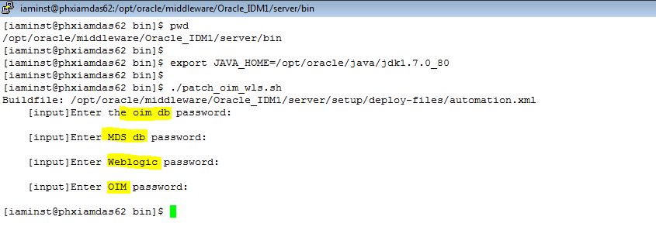

**Note:**

Make sure that Oracle Identity Manager is up and running when you run patch_oim_wls.sh or patch_oim_wls.bat.

4. Delete the following directory in domain home:

$ cd /opt/oracle/user_projects/domains/OIMDomain1/servers/oim_server1/tmp/_WL_user

$ rm –rf oracle.iam.console.identity.self-service.ear_V2.0

5. To verify that the patch_oim_wls script has completed successfully, check the /opt/oracle/middleware/Oracle_IDM1/server/bin/patch_oim_wls.log log file.

**Note:**

◦On running the patch_oim_wls script, the $DOMAIN_HOME/servers/MANAGED_SERVER/security/boot.properties file might be deleted. If you use a script to start the Managed Server and use the boot.properties file to eliminate the need of entering the password in the script, then create a new boot.properties file.

◦Ignore the following exception traces in the patch_oim_wls.log file:

[java] Aug 11, 2015 3:45:28 AM oracle.jdbc.driver.OracleDriver registerMBeans

[java] WARNING: Error while registering Oracle JDBC Diagnosability MBean.

[java] java.security.AccessControlException: access denied (javax.management.MBeanTrustPermission register)

[java] at java.security.AccessControlContext.checkPermission(AccessControlContext.java:374)

6. Stop Oracle Identity Manager managed Servers, SOA managed Servers and WebLogic Admin Server.

(Stop Order 🡪 oim_server1, soa_server1, oim_server2,soa_server2 and Admin server )

7. start WebLogic Admin Server, SOA managed Servers, and Oracle Identity Manager managed Servers.

(Start Order 🡪 Admin server, soa_server1, oim_server1, soa_server2 and oim_server2)

**6.4 Performing Post Patch Configuration for WebLogic Server**

If you are running Oracle Identity Manager on Oracle WebLogic Server, then perform the following configuration steps after applying the bundle patch:

1. Login to WebLogic Administrative Console.

2. Click **Lock and Edit**.

3. Go to **Environment**, **Work Managers**.

4. Create a new work manager OIMWorkManager and target it to OIM_SERVER or OIM_CLUSTER.

5. Modify the newly created OIMWorkManager, and select Maximum Threads Constraint property from the drop down.

**Note:**

**If OIMWorkManager already present, then click on OIMWorkManager and Save it.**

The value of the Maximum Threads Constraint property is configurable as per machine configuration. Recommended value for this property is 33. You can create new Maximum Threads Constraint variable, or you can use the existing one.

6. Save and activate the changes.

7. Stop Oracle Identity Manager managed Servers, SOA managed Servers and WebLogic Admin Server.

(Stop Order 🡪 oim_server1, soa_server1, oim_server2,soa_server2 and Admin server )

8. start WebLogic Admin Server, SOA managed Servers, and Oracle Identity Manager managed Servers.

(Start Order 🡪 Admin server, soa_server1, oim_server1, soa_server2 and oim_server2)

# **Manually Redeploying the Diagnostic Dashboard**

Applying this bundle patch does not upgrade or patch Diagnostic Dashboard. After applying the bundle patch, you must use the Oracle WebLogic Server Administrative Console to manually redeploy Diagnostic Dashboard using the XIMDD.ear file included in the bundle patch package.

/opt/oracle/middleware/Oracle_IDM1/server/webapp/optional/

To redeploy Diagnostic Dashboard using the WebLogic Administrative Console after applying the bundle patch:

1. Log in to the WebLogic Administrative Console.
2. Click **Deployments**, **Install**.
3. Identify the location of the Diagnostic Dashboard **XIMDD.ear** file.
4. Identify the system where you want to deploy the component.
5. Click **Finish**.

# **Manually Redeploying the SPML DSML Web Service**

Applying this bundle patch does not upgrade or patch SPML DSML. After applying the bundle patch, you must use the Oracle WebLogic Server Administrative Console to manually redeploy SPML DSML web service EAR by using the spml-dsml.ear file included in the bundle patch package.

To redeploy SPML DSML using the WebLogic Administrative Console after applying the bundle patch:

1. Log in to the WebLogic Administrative Console.
2. Click **Deployments**.
3. Select the checkbox for **spml-dsml.ear** file. This file is in the **/opt/oracle/middleware/Oracle_IDM1/server/apps/ directory**.
4. Click **Update**.
5. Click **Finish**.

# **Applying OIM Patch- 21197325 (if not applied earlier in both instances)**

1. Create a directory for storing the unzipped bundle patch. This document refers to this directory as PATCH_TOP. In our case its already created in First Patch so no need to create PATCH_TOP Folder.

$ cd /opt/oracle/middleware/Oracle_IDM1/OPatch/

$ mkdir PATCH_TOP

2. Copy the Patch "21197325" in PATCH_TOP folder

$ cd /opt/oracle/software/OIMPatching/25038775/iamsuite/patch/oim

$ cp -r 21197325 /opt/oracle/middleware/Oracle_IDM1/OPatch/PATCH_TOP

3. Move to the directory where the patch is located.

$ cd /opt/oracle/middleware/Oracle_IDM1/OPatch/PATCH_TOP/21197325

4. Apply the bundle patch to the ORACLE_HOME using the following command for WebLogic:

$ opatch apply

**Note:-**

When OPatch starts, it validates the patch and makes sure that there are no conflicts with the software already installed in the ORACLE_HOME.

OPatch categorizes two types of conflicts:

a. Conflicts with a patch already applied to the ORACLE_HOM. In this case, stop the patch installation, and contact Oracle Support Services.

b. Conflicts with subset patch already applied to the ORACLE_HOME. In this case, continue the install, as the new patch contains all the fixes from the existing patch in the ORACLE_HOME.

**Verify both Patches are Installed-**

Run below command for listing the applied patches-

opatch lsinventory

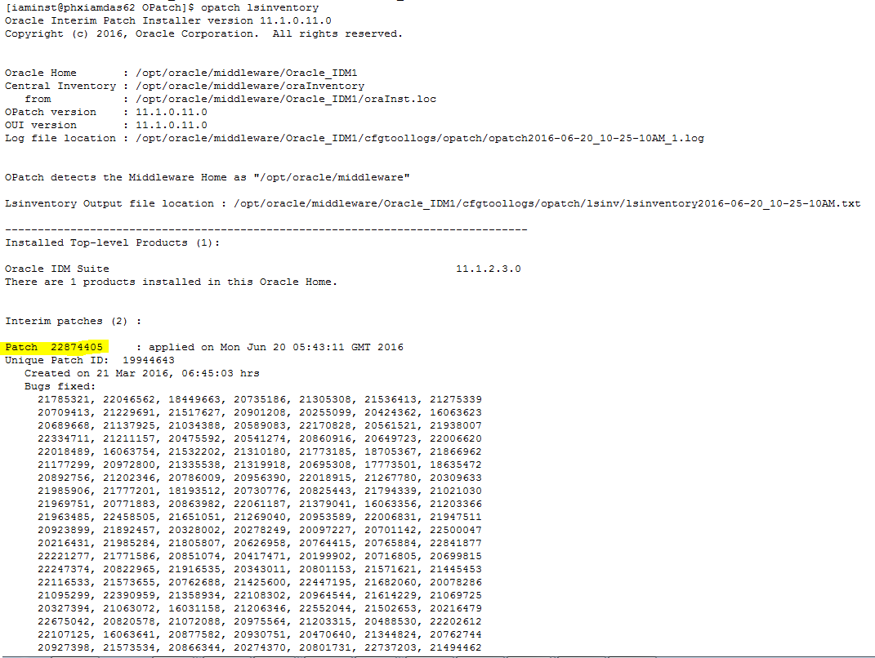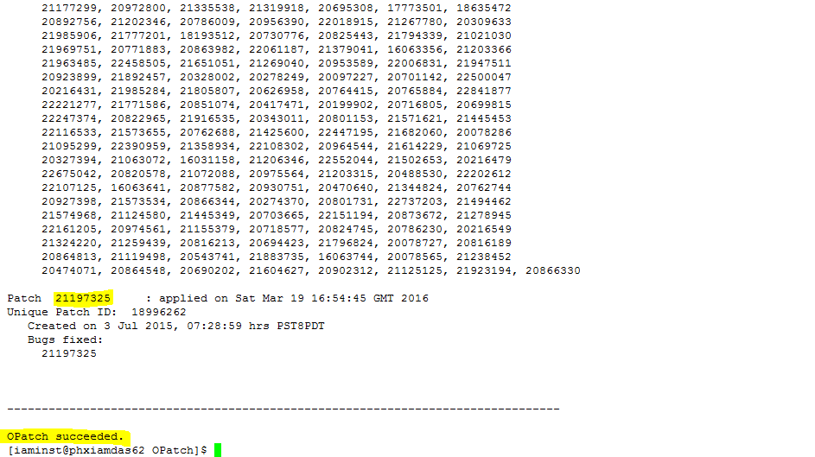

**Testing-**

After applying the patch verify the Create User, Update User and Modify User flow and also the other links are working fine or not.

## **Applying the Database Patch (Mandatory) DB team have to work**

After applying Bundle Patch 11.1.2.3.170117, you must apply a mandatory database patch to avoid Interested Transaction Lists (ITL) waits on the database tables ENT_ASSIGN and OIU and their indexes.

This section describes the procedure to apply the database patch. It contains the following topics:

* Section 10.1, "Prerequisites"
* Section 10.2, "Installing the Patch"
* Section 10.3, "Verifying the Results"

### 10.1 Prerequisites

Before applying the database patch:

1. Bundle Patch 11.1.2.3.170117 must be applied.
2. Oracle Identity Manager Server must be shut down.

### 10.2 Installing the Patch

To install the database patch:

1. Connect to the target instance in any one of the following ways:
   * Connect to target instance with OIM schema using SQLPLUS. The command is:

sqlplus <OIM_SCHEMA>/<PASSWORD>@<TNS_STRING>

* + Connect to target instance from SYS DB user by switching CURRENT_SCHEMA to OIM schema. The command is:
  + sqlplus / as sysdba
  + ALTER SESSION SET CURRENT_SCHEMA=<OIM_SCHEMA_NAME>;

1. Run the following SQl command:

SQL> @oim11gr2ps3_initrans_postinstallation.sql

The following message is printed on the SQL Plus prompt:

PATCH STARTED

TABLE ENT_ASSIGN INITTRANS VALUE HAS BEEN MODIFIED SUCCESSFULLY

TABLE ENT_ASSIGN PCTFREE VALUE HAS BEEN MODIFIED SUCCESSFULLY

TABLE OIU INITRANS VALUE HAS BEEN MODIFIED SUCCESSFULLY

TABLE OIU PCTFREE VALUE HAS BEEN MODIFIED SUCCESSFULLY

INDEX PK_ENT_ASSIGN INTRANS VALUE HAS BEEN MODIFIED SUCCESSFULLY

INDEX PK_ENT_ASSIGN PCTFREE HAS BEEN MODIFIED SUCCESSFULLY

INDEX UK_ENT_ASSIGN INTRANS VALUE HAS BEEN MODIFIED SUCCESSFULLY

INDEX UK_ENT_ASSIGN PCTFREE HAS BEEN MODIFIED SUCCESSFULLY

INDEX IDX_ENT_ASSIGN_USR_KEY INTRANS VALUE HAS BEEN MODIFIED SUCCESSFULLY

INDEX IDX_ENT_ASSIGN_USR_KEY PCTFREE HAS BEEN MODIFIED SUCCESSFULLY

INDEX IDX_ENT_ASSIGN_OIU_KEY INTRANS VALUE HAS BEEN MODIFIED SUCCESSFULLY

INDEX IDX_ENT_ASSIGN_OIU_KEY PCTFREE HAS BEEN MODIFIED SUCCESSFULLY

INDEX IDX_ENT_ASSIGN_UD_CHILD_KEY INTRANS VALUE HAS BEEN MODIFIED SUCCESSFULLY

INDEX IDX_ENT_ASSIGN_UD_CHILD_KEY PCTFREE HAS BEEN MODIFIED SUCCESSFULLY

INDEX IDX_ENT_ASSIGN_ENT_LIST_KEY INTRANS VALUE HAS BEEN MODIFIED SUCCESSFULLY

INDEX IDX_ENT_ASSIGN_ENT_LIST_KEY PCTFREE HAS BEEN MODIFIED SUCCESSFULLY

INDEX PK_OIU INTRANS VALUE HAS BEEN MODIFIED SUCCESSFULLY

INDEX PK_OIU PCTFREE HAS BEEN MODIFIED SUCCESSFULLY

INDEX IDX_OIU_ORC_KEY INTRANS VALUE HAS BEEN MODIFIED SUCCESSFULLY

INDEX IDX_OIU_ORC_KEY PCTFREE HAS BEEN MODIFIED SUCCESSFULLY

INDEX IDX_OIU_REQ_KEY INTRANS VALUE HAS BEEN MODIFIED SUCCESSFULLY

INDEX IDX_OIU_REQ_KEY PCTFREE HAS BEEN MODIFIED SUCCESSFULLY

INDEX IDX_OIU_USR_KEY INTRANS VALUE HAS BEEN MODIFIED SUCCESSFULLY

INDEX IDX_OIU_USR_KEY PCTFREE HAS BEEN MODIFIED SUCCESSFULLY

INDEX IDX_OIU_OBI_KEY INTRANS VALUE HAS BEEN MODIFIED SUCCESSFULLY

INDEX IDX_OIU_OBI_KEY PCTFREE HAS BEEN MODIFIED SUCCESSFULLY

INDEX IDX_OIU_OST_KEY INTRANS VALUE HAS BEEN MODIFIED SUCCESSFULLY

INDEX IDX_OIU_OST_KEY PCTFREE HAS BEEN MODIFIED SUCCESSFULLY

INDEX IDX_OIU_APP_INSTANCE_KEY INTRANS VALUE HAS BEEN MODIFIED SUCCESSFULLY

INDEX IDX_OIU_APP_INSTANCE_KEY PCTFREE HAS BEEN MODIFIED SUCCESSFULLY

INDEX FDX_OIU_ACCOUNT_TYPE INTRANS VALUE HAS BEEN MODIFIED SUCCESSFULLY

INDEX FDX_OIU_ACCOUNT_TYPE PCTFREE HAS BEEN MODIFIED SUCCESSFULLY

INDEX IDX_OIU_COMPOSITE INTRANS VALUE HAS BEEN MODIFIED SUCCESSFULLY

INDEX IDX_OIU_COMPOSITE PCTFREE HAS BEEN MODIFIED SUCCESSFULLY

TABLE ENT_ASSIGN HAS BEEN MODIFIED

TABLE OIU HAS BEEN MODIFIED

INDEX PK_ENT_ASSIGN REBUILD SUCCESSFULLY

INDEX UK_ENT_ASSIGN REBUILD SUCCESSFULLY

INDEX IDX_ENT_ASSIGN_USR_KEY REBUILD SUCCESSFULLY

INDEX IDX_ENT_ASSIGN_OIU_KEY REBUILD SUCCESSFULLY

INDEX IDX_ENT_ASSIGN_UD_CHILD_KEY REBUILD SUCCESSFULLY

INDEX IDX_ENT_ASSIGN_ENT_LIST_KEY REBUILD SUCCESSFULLY

INDEX PK_OIU REBUILD SUCCESSFULLY

INDEX IDX_OIU_ORC_KEY REBUILD SUCCESSFULLY

INDEX IDX_OIU_REQ_KEY REBUILD SUCCESSFULLY

INDEX IDX_OIU_USR_KEY REBUILD SUCCESSFULLY

INDEX IDX_OIU_OBI_KEY REBUILD SUCCESSFULLY

INDEX IDX_OIU_OST_KEY SUCCESSFULLY

INDEX IDX_OIU_APP_INSTANCE_KEY REBUILD SUCCESSFULLY

INDEX FDX_OIU_ACCOUNT_TYPE REBUILD SUCCESSFULLY

INDEX IDX_OIU_COMPOSITE REBUILD SUCCESSFULLY

PATCH ENDED

If these messages are displayed, then the patch has been applied successfully. Otherwise, contact Oracle Support.

### 10.3 Verifying the Results

After installing the database patch, verify the results by running the following SQL queries.

Run the following query:

SELECT TABLE_NAME,PCT_FREE,INI_TRANS FROM USER_TABLES WHERE TABLE_NAME IN ('ENT_ASSIGN','OIU');

The following result should be displayed:

TABLE_NAME PCT_FREE INI_TRANS

ENT_ASSIGN 20 30

OIU 20 30

Run the following query:

SELECT TABLE_NAME,INDEX_NAME,INDEX_TYPE,PCT_FREE,INI_TRANS FROM USER_INDEXES WHERE TABLE_NAME IN ('ENT_ASSIGN','OIU') AND INDEX_TYPE <> 'LOB';

The following result should be displayed:

TABLE_NAME INDEX_NAME INDEX_TYPE PCT_FREE INI_TRANS

OIU IDX_OIU_COMPOSITE NORMAL 20 30

OIU FDX_OIU_ACCOUNT_TYPE FUNCTION-BASED NORMAL 20 30

OIU IDX_OIU_APP_INSTANCE_KEY NORMAL 20 30

OIU IDX_OIU_OST_KEY NORMAL 20 30

OIU IDX_OIU_OBI_KEY NORMAL 20 30

OIU IDX_OIU_USR_KEY NORMAL 20 30

OIU IDX_OIU_REQ_KEY NORMAL 20 30

OIU IDX_OIU_ORC_KEY NORMAL/REV 20 30

OIU PK_OIU NORMAL 20 30

ENT_ASSIGN IDX_ENT_ASSIGN_ENT_LIST_KEY NORMAL 20 30

ENT_ASSIGN IDX_ENT_ASSIGN_UD_CHILD_KEY NORMAL 20 30

ENT_ASSIGN IDX_ENT_ASSIGN_OIU_KEY NORMAL 20 30

ENT_ASSIGN IDX_ENT_ASSIGN_USR_KEY NORMAL 20 30

ENT_ASSIGN UK_ENT_ASSIGN NORMAL 20 30

ENT_ASSIGN PK_ENT_ASSIGN NORMAL 20 30